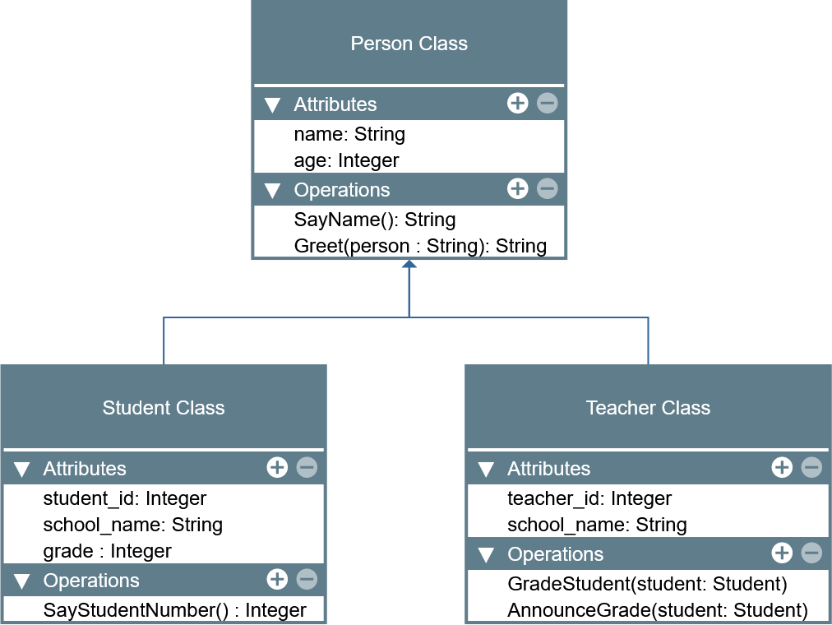

LABORATORY MANUAL

Object-Oriented Programming (CPE 103)

|  |  |
| --- | --- |
| **Laboratory Activity No. 2.2** | |
| **Literals, Operators, and Variables** | |
| **Course Code:** CPE103 | **Program:** BSCPE |
| **Course Title:** Object-Oriented Programming | **Date Performed:** February 1,2025 |
| **Section:** 1-A | **Date Submitted:** February 1, 2025 |
| **Name:** Polestico,Paul Justine D. | **Instructor:** Engr. Maria Rizette Sayo |
| **1. Objective(s):** | |
| 1. Implement literals and variables in a phyton program. | |
| **2. Intended Learning Outcomes (ILOs):** | |
| The students should be able to:   1. Write a simple program implementing literals and variables. 2. Use and identify keywords from identifiers created by users. | |
| **3. Discussion:** | |
| In continuation of the lesson, We will discuss about variables,constants and literals. Starting with the variables, it is like a label that can be used to store a value. An example would be:  name=”Paul”  The label “Name” is where i stored my name, Which is Paul. You can even change the value if you wanted to,in this case being “Paul”.  Literals,are like what constants are in mathematics. They represent a fixed value that the programmer assigned.  For Example:  X=5  y=x*2  y=10  Lastly,constants are variables whose values are intended to remain unchanged throughout a program. For Example:  GRAVITY= 9.8 and PI= 3.14 | |
| **4. Materials and Equipment:** | |
| Desktop Computer with Anaconda Python /Python Colab Windows Operating System | |
| **5. Procedure:** | |
| **Perform the activity using the Jupyter Notebook**  This activity can be done either locally on Anaconda’s Jupyter Notebook or online through Google Collaboratory which offers a free Jupyter Notebook environment for Google Users. IPython Notebook files (.ipynb) that are saved in the Google Drive can be opened on Google Collaboratory. Additional guides are available on the IPython Notebook template file that is provided wit h  this activity. If the template is not present, these are the valuable links for reference: | |

|  |
| --- |
| <https://jupyter-notebook.readthedocs.io/en/stable/examples/Notebook/Notebook%20Basics.html> <https://colab.research.google.com/notebooks/welcome.ipynb> <https://colab.research.google.com/notebooks/markdown_guide.ipynb>    **Calculating the Final Grade in a CpE Course using Literals,Constants and Variables**   1. A teacher wants to calculate the final grade in a CpE course and   want to write it in a phyton program. The following program are the  requirements:   1. PRELIM GRADE = 50% Prelim Exam + 50% Prelim Class   Standing (CS)   1. PRELIM CS= 50% Hands-on activity + 30% Quiz + 20%   Assignment   1. MIDTERM GRADE= 1/3 of PRELIM GRADE + 2/3 of   (50% Midterm Exam + 50% Midterm Class Standing (CS)   1. MIDTERM CS = 50% Hands-on activity + 30% Quiz +   20% Assignment   1. FINAL GRADE= 1/3 of MIDTERM GRADE + 2/3 of (50%   Final Exam + 50% Final Class Standing (CS)   1. FINAL CS= 50% Hands-on activity + 30% Quiz + 20%   Assignment   1. HOAs, Quizzes and Assignments are inputted as average   of all submissions and are out of 100%   1. Major Exam are inputted out of 100% 2. Show the codes that successfully run the program. 3. Provide comments or documentation strings for your   Program. |
|  |
|  |
| **6. Supplementary Activity:** |
| **Tasks**   1. Test 3 students from the program you created 2. The program should show the name of the student, the PRELIM,   MIDTERM and FINAL GRADES.   1. Convert the final grade into the UCCs numerical grade. Please refer   to the grading system.   1. Document your lab activity properly using Markdown codes. 2. Answer all the supplementary activities (programs and questions.) 3. Write your conclusion. 4. Convert your notebook into a PDF file and submit the PDF to the link. |
|  |

|  |
| --- |
|  |
| **7. Conclusion:** |
| This laboratory taught me how to implement variables,constants and literals.I learned how to set variables,constants and literals in order to assign values, calculate constants,and literals while using the if else statement in case the computed output has different outcomes.  References:  B. Kumar, “Python Variables - Complete Guide - Python Guides,” *Python Guides*, Aug. 14, 2024. <https://pythonguides.com/python-variables/>  GeeksforGeeks, “Python Constant,” *GeeksforGeeks*, Dec. 30, 2024. <https://www.geeksforgeeks.org/python-constant/>  “Python Literals: Types, usages, and examples.” <https://www.tutorialspoint.com/python/python_literals.htm>  Please refer to this link:  <https://github.com/PaulJustinePolestico/CPE-103-OOP-1-A/blob/main/Laboratory_Activity_2_2.ipynb> |
| 1. **Assessment Rubric:** |